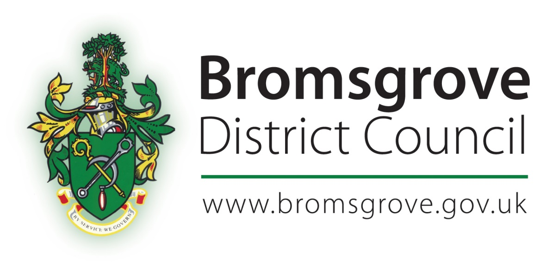

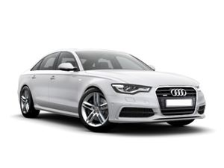

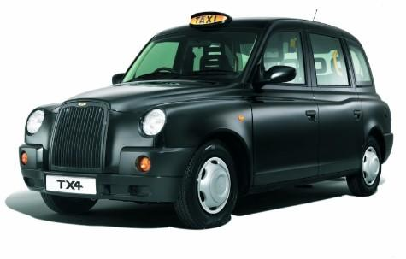

Hackney Carriage and Private Hire Consultation

December 2017

Bromsgrove District Council

Hackney Carriage and Private Hire Consultation
December 2017

Bromsgrove District Council’s policies on the licensing of hackney carriage and private hire vehicles, operators and drivers are contained within the Council’s “Hackney Carriage and Private Hire Handbook.” The current version of this document was approved by the Licensing Committee with effect from 1 April 2016.

The Council keeps all its policies under review to ensure they remain fit for purpose and will consider amendments when appropriate.

There are two particular areas in the existing policies that have created difficulties for licence holders and the Council since the current Hackney Carriage and Private Hire Handbook was approved. These are:

- The requirement for those issued licences to drive hackney carriage and/or private hire vehicles to obtain an NVQ Level 2 in Road Passenger Vehicle Driving

- The requirements relating to the level of tint that is acceptable on the windows of hackney carriage and private hire vehicles.

In light of the difficulties being experienced, the Licensing Committee has decided to carry out consultation on some proposals that may address the problems that have arisen.

Please use this consultation questionnaire to give your thoughts and feedback on the proposals under consideration. Once complete, please return the consultation questionnaire by email to enquiries@worcsregservices.gov.uk using the subject line “Bromsgrove Taxi Consultation”

Alternatively you can post your response to:

Bromsgrove Taxi Consultation
Worcestershire Regulatory Services
Wyre Forest House
Finepoint Way
Kidderminster
Worcestershire
DY11 7WF

This consultation will be open for responses until Friday 16th February 2018 and all responses received will be given consideration by the Council’s Licensing Committee before any decisions about whether to implement any of the proposals are taken.
Part A – | Requirement to Obtain an NVQ Level 2 in Road Passenger Vehicle Driving

The Council’s current driver licensing policy includes the following requirement:

“New holders of driver licences are required to be awarded an NVQ Level 2 in Road Passenger Vehicle Driving or equivalent qualification within twelve months from the date of the grant of their initial licence.”

The qualification was set up with the aim of contributing to the skills, knowledge and overall performance of individuals who are employed in providing a community transport service, taxi and/or private hire. This qualification is based on the latest National Occupational Standards.

To achieve a full Level 2 NVQ Certificate in Road Passenger Vehicle Driving (Community Transport, Taxi and Private Hire), learners must achieve a minimum of 31 credits from mandatory and optional groups. Mandatory units cover health and safety, driving community transport/ chauffeured vehicles safely and efficiently, providing professional customer services and services for those who require assistance, dealing with difficult situations and emergencies and working with others.

Learners may choose from a range of optional units according to their job role. These include defensive driving, meeting special customer needs, providing a service to children and young people, processing telephone bookings, transporting luggage and parcels, planning routes and processing fares.

Some licence holders have reported difficulties in obtaining the NVQ or an equivalent qualification as they state there are very few training providers who are still offering the qualification in the local area. Licence holders have also complained that the costs of obtaining the qualification are unduly burdensome.

When the requirement was first introduced at Bromsgrove, there was Government funding in place to pay for the training so as to encourage uptake of the qualification amongst licensed drivers across the country. This funding is apparently no longer being widely provided, so those undertaking the qualification need to fund it themselves.

Bromsgrove District Council is the only licensing authority in Worcestershire that currently requires its licensed drivers to obtain the NVQ Level 2 in Road Passenger Vehicle Driving.

The Council is therefore considering a proposal to remove the requirement to obtain the NVQ and replace this with a requirement for all new licence holders to undertake disability awareness training before they are licensed instead.

There are a number of providers of disability awareness training for licensed drivers, including some organisations that provide online training solutions. If this proposal was implemented, the Council would approve training providers that licence holders could undertake their training with.
Do you agree with the proposal to remove the requirement to obtain the NVQ and replace this with a requirement for all new licence applicants to undertake approved disability awareness training BEFORE they are licensed?

YES | NO
Do you have any further comments to make in relation to the proposal under consideration?

Part B – | Acceptable Level of Tint on Windows of Licensed Hackney Carriage and Private Hire Vehicles

The Hackney Carriage and Private Hire Handbook states:

“Any vehicle to be licensed for the first time, with the exception of special event vehicles, is NOT permitted to have a tint where they conceal the identity of the passenger inside. The Licensing Officer will examine a vehicle prior to test to ensure that the level of tint on the windows does not conceal the identity of passengers inside the vehicle.”

Licence holders have raised concerns that the majority of vehicles manufactured at present are fitted with some level of tint on the windows as standard. Licence holders have complained that the costs involved in replacing the glass in the windows so that the vehicle complies with the requirements in the Hackney Carriage and Private Hire Handbook are unduly burdensome.

To try and address some of the concerns raised, the Council’s Licensing Committee is considering implementing one of the following five options:

Option A | Remove the requirement from the handbook altogether. This would mean that, provided that the glass complies with the Con and Use Regs, the vehicle would be acceptable for licensing as a hackney carriage or private hire vehicle
Option B | To remove the requirement from the handbook and replace it with a requirement that the windows of the vehicle allow a defined amount of visible light to be transmitted through the glass. The precise amount of visible light to be transmitted would be set following further research and consultation.
Option C | To remove the requirement from the handbook and replace it with a requirement that the vehicle windows cannot be fitted with privacy glass (entirely black or reflective glass).
Option D | To remove the requirement from the handbook and replace it with a requirement that the glass is to factory standard and vehicles are presented to licensing in an unmodified state, vehicles fitted with films, foils, or any other aftermarket tinting will be refused a licence, unless the tinting is removed and the vehicle returned to the manufacturer’s standard specification.
Option E | Leave the wording in the handbook as it is currently

Please place each of these options in your order of preference

 | 1st Preference | Option
 | 2nd Preference | Option
 | 3rd Preference | Option
 | 4th Preference | Option
 | 5th Preference | Option

Do you have any other comments to make in relation to this area of the Council’s vehicle licensing policies?

In what capacity are you responding to this consultation?

Licensed Hackney Carriage / Private Hire Driver |  | Licensed Private Hire Operator
Member of the Public |  | Elected representative
Other (please specify)

Once complete, please return the consultation questionnaire by email to enquiries@worcsregservices.gov.uk using the subject line “Bromsgrove Taxi Consultation”

Alternatively you can post your response to:

Bromsgrove Taxi Consultation
Worcestershire Regulatory Services
Wyre Forest House
Finepoint Way
Kidderminster
Worcestershire
DY11 7WF

This consultation will be open for responses until Friday 16th February 2018 and all responses received will be given consideration by the Council’s Licensing Committee before any final decisions about whether to implement any of the proposals are taken.

