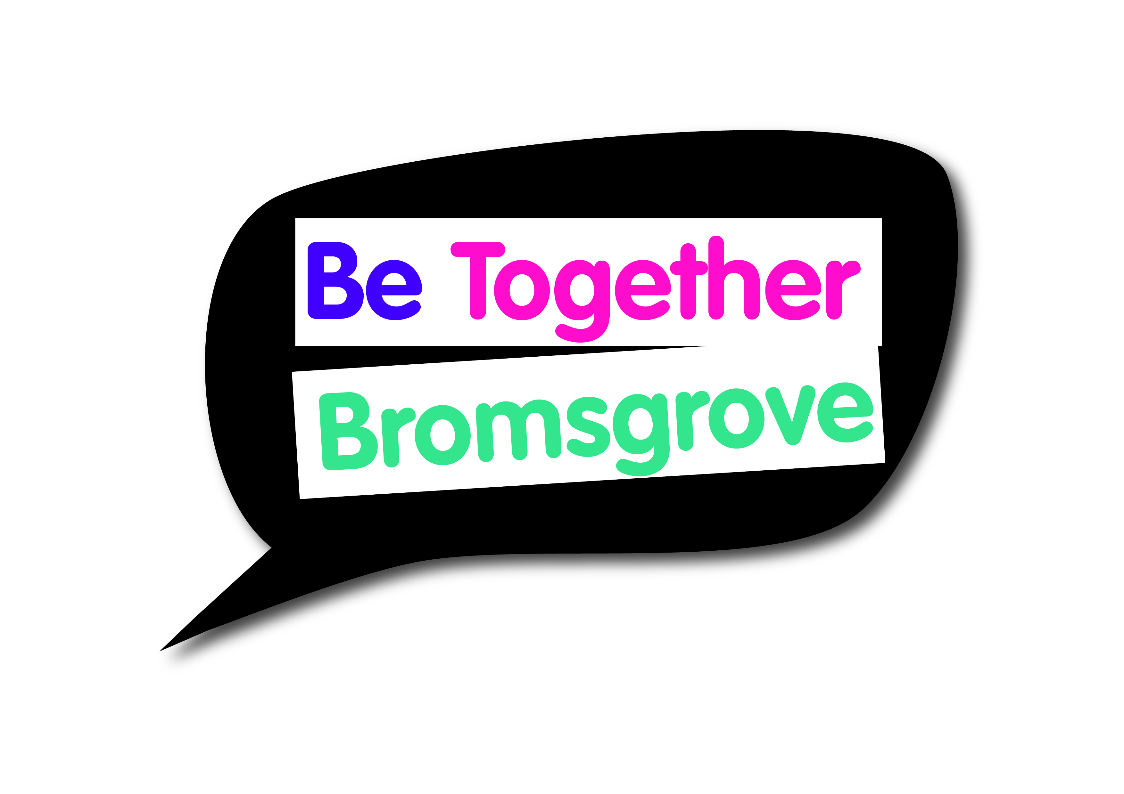
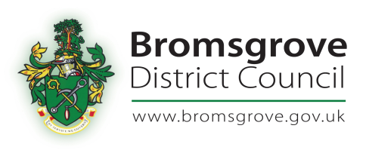
Bromsgrove Engagement & Equalities Forum
Minutes of meeting on
Thursday 7 December 2017

Present:
14 Forum members

- Introductions and apologies
Everyone was welcomed by the Chair. Introductions were made and apologies noted.

- Draft minutes of meeting held on 7 September 2017
The minutes were agreed

- Delivery of the Forum in 2018
Becky and Emily will both be on maternity leave during 2018. Becky will be leaving in Dec and Emily in Jan.
Rachel Betteridge, who very kindly came to the forum to be introduced, will be starting on Monday 18 Dec for a year’s maternity cover. Rachel will be co-ordinating the forums meetings and supporting Ann Dallison, Grants Officer, with the BDC Small Grants Scheme.

- Presentations from groups who received a grant from BDC Small Grants Round 1 and 2 2017/18
The Alzheimer’s Society received £500 to support the delivery of a pop-up Dementia Café in Cathill and Wythall. They have been a success and a number of people from the community have come along. Over 45 surveys were completed at the event held at Becketts Farm. A permanent Dementia Café is now set up at Wythall village Hall from 2-4pm and the first will take place on Wed 20 Dec and then 3rd Wed of the month. Becketts Farm is also looking at setting up a Dementia Café.
Mr C praised the group for their work and the forum members would really like to take this work forward by encouraging other Parishes to deliver Dementia Cafes.

Bromsgrove Methodist Church received £500 to support the delivery of the Holidays at Home project. The project is based on Imaginary holidays for those no longer able to actually go away. Each day a different destination with meals and activities linked to the place. After welcome teas and coffee a short talk with visual aids to remind or inform about the destination.

Emily gave a quick update about the 14 groups that received grants in 2017/18 Round 2.

- Bromsgrove Car Park Review update
Cheryl was unable to attend the meeting so item is to be deferred to the March meeting

- Update on BURT and Rural Rides
BURT stands for Bromsgrove Urban Rural Transport and BARN took over the running of the service about a year ago from the District Council. They have one minibus and able to use it within the boundary of the district. Each week 70-80% of their users are regular. It costs £2 and then 40p per mile. Currently they are not providing a service at the weekends due to no volunteers. The running costs come from fares, the council and Government.
BURT and Rural Rides are looking at a combined bid for an adapted vehicle.

Rural Rides is operated by volunteers using their own cars to get people around the district and further afield. Approx 80% are for hospital and GP appointments covering Worcester Royal, Coventry and Birmingham. They have just taken on more volunteers so can take an average of 10-15 new passengers a week.

- Update from Bromsgrove and Redditch Welcomes Refugees
Margaret read out an update from BRWR.

- Future topics for discussion/agenda item
Planning for future meetings will mean the forum can have the right people come to give presentations. Following discussions some of the agenda items for the future included –

Promoting the Herbert Protocol - https://www.westmercia.police.uk/article/20154/The-Herbert-Protocol

Feedback of the results from the Bromsgrove Community Panel

Bromsgrove Car park review

- Any Other Business including questions for the Chief Executive Officer

BARN has set up a new free funding portal https://barn.org.uk/funding/ to assist all voluntary and community groups in the area.

- Meetings for 2018

Thursday 1 March
Thursday 7 June
Thursday 6 September
Thursday 6 December

All meetings will be held in the Committee Room at Parkside. Refreshments from 5.30pm with the meeting starting 6pm to 8pm
Unfortunately, there is no parking, except for Blue Badge holders. Alternative parking in Bromsgrove is available at http://www.bromsgrove.gov.uk/my-place/parking/our-car-parks.aspx

