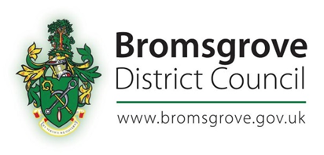

Bromsgrove District Council
The Local Authorities (Referendums)(Petitions)(England) Regulations 2011

Publication of Verification Number

In accordance with Regulation 4(1) of the above regulations the number that is equal to 5% of the number of local government electors shown in the revised register of electors having effect on the 15th February 2018 is:

3607

This figure will have effect for the purposes of determining the validity of Petitions presented from 1st April 2018 to 31st March 2019.

The number equal to 5% of the local government electors for 2019 will be published within 14 days of the 15th February 2019. If this number is less than 3607, the number to be used for verification purposes in relation to any petition submitted for the period beginning on the date of publication of the lower number until 31st March 2019 shall also be that lower number.

Kevin Dicks
Electoral Registration Officer
Bromsgrove District Council
Parkside
Market Street
Bromsgrove
Worcestershire
B61 8DA
20 February 2018

