BROMSGROVE DISTRICT COUNCIL

New Homes Bonus Community Grants Scheme 2018/19
Explanatory Notes
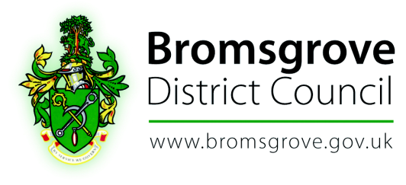
CONTENTS
- Introduction – where does the NHB fund come from?

- Who can apply for a grant?

- What are the criteria for awarding a grant?

- The Council’s Strategic Purposes.

- Who determines grant applications?

- How grants are paid and any conditions attached to them.

- Monitoring Projects

- What happens if a bid isn’t successful?

- The Grant Application Process Timetable.

- Contacts and where to find more information.

- Supporting Documentation

- Introduction - Where does the New Home Bonus come from?
The New Homes Bonus is paid annually by the government as an incentive to communities and councils to welcome new housing. At present, for a period of six years following the year the house was built, the council receives a grant that is payable on those new homes plus any homes that were empty and have been brought into use. As part of the announcement on the Financial Settlement 2017/18-2020/21, the Government has confirmed that there will be changes to the New Homes Bonus Scheme which will reduce the available funding for future years.

At present, the New Homes Bonus is announced alongside our annual financial settlement. In two tier areas, like Worcestershire, the bonus is shared between the District Council and the county council (80% / 20%). The District Council therefore receives 80% of the total New Homes Bonus. This may also change as part of the final scheme following consultation.

At present, the grant is not ring fenced and therefore the Council is free to decide how to use the grant. There has been encouragement from Central Government for the funding to be utilised within communities however this does not form any legislative requirement.

For the financial year 2018/19 the Council has once again decided to make part of the New Homes Bonus available for a New Homes Bonus Community Grants Scheme.

Bromsgrove District Council has agreed that the allocation available for the scheme is to be £79,000 (25% to be based on the District Council grant which will be received in 2018/19 which is attributed solely to the increase in funding from that received in 2017/18). No allocation will be made from the New Homes Bonus that is being paid for previous years. .

Following a full and comprehensive review of the Scheme in 2017/18, Members of the Panel have agreed that there will be no changes made to the Scheme for 2018/19. A project needs to be able to provide clear evidence how the community has been affected by growth and that this growth will be met by the project. Full details of who can apply are provided in section 2.

This Scheme will run for 12 months and be reviewed as part of the budget process for the financial year 2019/20.

- Who Can Apply for a Grant?
The New Homes Bonus Community Grants Scheme is intended for not-for-profit groups, such as voluntary organisations, residents’ groups, community groups and associations including Parish Councils within those areas affected. Organisations outside the District may also apply where they are delivering projects/activities that benefit the District.

Grants will not be paid to individuals.

You will need to provide full details of your organisation when completing the application form. The relevant Ward Councillor will also need to sign the application form and provide a statement as to why they support your project (including highlighting how it meets the Council’s strategic priorities).

- What are the Criteria for Awarding a Grant?

Projects should be substantial and sustainable and provide a legacy for the areas in which they are located whilst also being in line with the Council’s strategic purposes (detailed at section 4 of these explanatory notes). The key element of these criteria is ensuring that funded projects complement the Council’s long term strategic priorities.

Each organisation may bid for either up to 2% of the overall funding, £1,580 or for higher bids up to 20% of the available fund (£15,800). Applications in excess of £1,581 will need to provide a more detailed application and supporting documentation including a business plan.

The Panel will not usually consider more than one application from the same organisation within the 12 month period unless they are clearly for separate projects.

Priority will be given to applications according to the following criteria:

- Meet at least one of the Council’s strategic purposes (see section 4 for full details.)
- The impact of growth on the relevant area
- Proposals demonstrate the basis of need or demand as well as the benefits
- Projects must be sustainable.
- All applicants agree to acknowledge the Council as a funder of the project.
- All funded projects keep full records of their activities and how the grant has been spent
- Proposals should outline how they will address the impact (actual and anticipated) of growth.
- The names of other organisations that have been approached for funding.
- The total cost and timescales of the project.
- The communities that will be served by the project.
- Support (including a comprehensive written statement) from the Ward Councillor.

- Bromsgrove District Council’s Strategic Purposes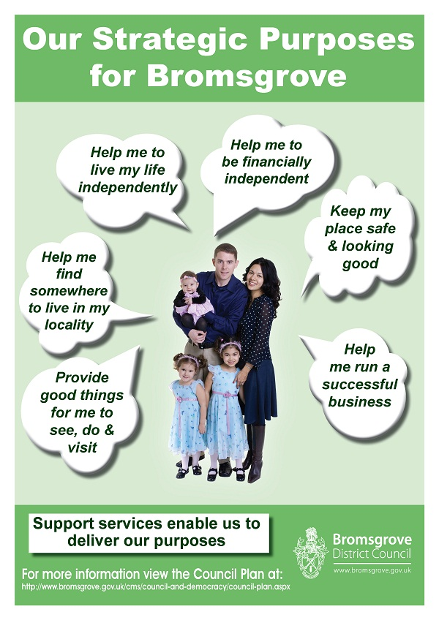
- Who Determines Grant Applications?
Officers of the Council will assess applications to ensure they satisfy the criteria for eligibility, whether any further information is required and whether costs are realistic relative to the proposals and the funds available.

Applications which are clearly ineligible or inappropriate may be rejected with the agreement of the Chairman of the New Homes Bonus Community Grants Panel. Otherwise officers will prepare a report for the Panel, summarising each bid and making a recommendation.

The New Homes Bonus Community Grants Panel, comprising of Councillors (the Portfolio Holder for Finance and Resources together with a representative from each political group) will meet in July. They are supported by officers and the meeting will be held in public.

Applicants will be invited (and encouraged) to attend the meeting in order to respond to questions or points of clarification from the Panel.

The New Homes Bonus Community Grants Panel will then make a recommendation to the Council’s Cabinet. Any interested party can make representations in writing, which will be reported to Cabinet. The Cabinet meetings are also open to the general public.

A full timetable is detailed at section 9 of these explanatory notes and sets out the exact dates of when the invitation for applicants will be opened and the closing date for applications, together with details of when the New Homes Bonus Community Grants Panel recommendations will be considered by Cabinet. Following approval of those recommendations the successful applicants will be contacted and provided with details of when the monies from successful bids will be paid.

- How Grants are Paid and any Conditions attached to them.
A funding agreement will be signed and will include standard conditions, for example:

- Timescales for the project and a schedule of funding payments
- That the contribution made by the NHB Grants Scheme must be clearly identified to the local community.

Other conditions of funding may be included, depending on the nature of each project. All projects must be completed by the end of the financial year 2018/19 unless otherwise agreed by the New Homes Bonus Community Grants Panel.
If part-funding is agreed proof must be given as to where the other money is coming from.

A payment schedule will be agreed as part of the Funding Agreement for each successful application. Dependent upon the amount of the grant this could be phased to meet the forecast spend of the project or a one off payment for a small project.

Monitoring requirements will be dependent on the size and scale of the project and will be agreed for each individual project as part of the conditions of the funding. Any phased payments would be released subject to satisfactory monitoring/progress.

It is important to inform the Council of any delays or changes in plans as this may impact on future phased payments or a request for the return of the grant. It cannot be transferred to another project.

- Monitoring Projects

If a single payment has been agreed evidence would be required to show that the project has been completed as agreed.
If payment is through a phased programme we will need evidence to show that each phase has been completed within the timescale given.
You will receive a reminder asking for a progress report 12 months after the decision has been made to give you a grant and every 6 months thereafter until the project has been completed. We would expect the progress report to include photographic evidence of the work being undertaken.
- What Happens if a Bid is not successful?
If a bid is not successful you will be advised and given the reasons. In exceptional circumstances the Panel may request some more information and offer to reconsider the bid at a future meeting.

There is no appeals process, however if you are refused a grant you can still apply for future/alternative projects providing they meet the Council’s criteria.

- The Grant Application Process Timetable

Timetable
Date Applications Open | Date Applications Close
9.00 a.m. Tuesday 8th May 2018 | 5.00 p.m. Friday 15th June 2018

For the first time, this year there will be an opportunity for applicants to have their submissions verified, giving them an opportunity to be resubmitted prior to the closing date. This will apply to applications received no later than 9 am on 30th May 2017. Any incomplete application received after that date will be automatically rejected.

Date of New Homes Bonus Grants Panel Meeting | Date of Cabinet Meeting
4.00 pm Thursday 19th July 2018 and  (Tuesday 31st July 2018 if required) | 6.00 p.m. Wednesday 5th September 2018

- Contacts and Where to find more information
New Homes Bonus Community Grants Panel Members
The Panel is made up of a Councillor Representative from each political group together with the Portfolio Holder for Finance and Enabling.

Supporting Officers

Jayne Pickering – Executive Director, Finance and Resources
Amanda Scarce – Senior Democratic Services Officer

- Documentation

Application Form - Lower grants up to £1,580
Application Form - Higher grants between £1,581 and £15,800
FQAs
Timeline

