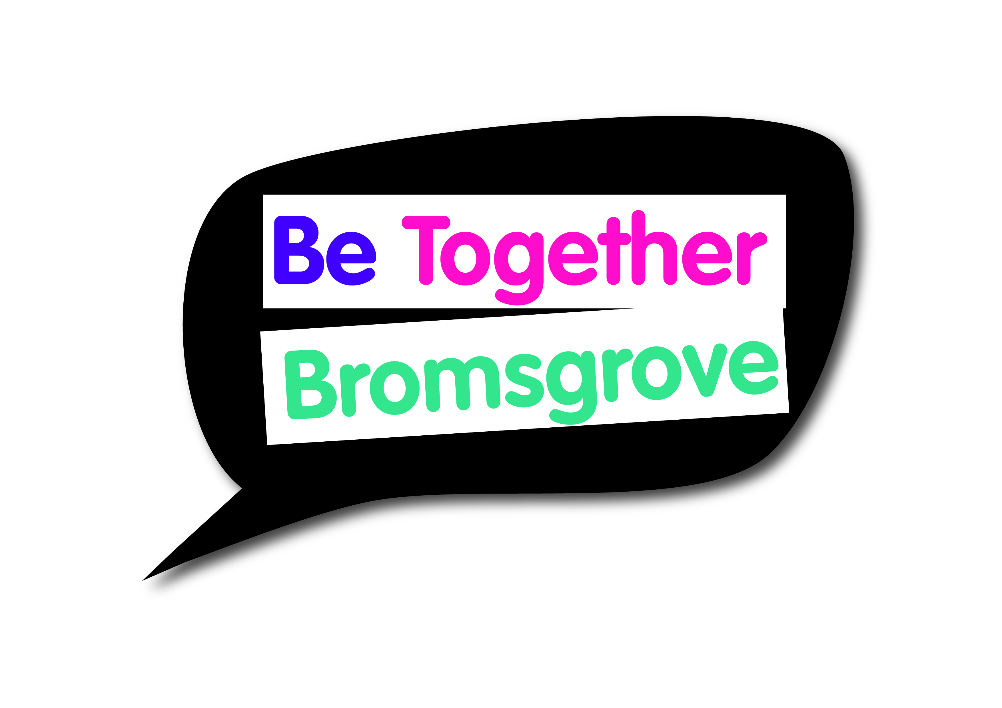

Bromsgrove Engagement & Equalities Forum
Minutes of meeting on Thursday 7 June 2018

Attending
21 Attendees

- Introductions and minutes
Everyone was welcomed by C. Introductions were made and minutes agreed. The forum wish to send their good wishes to Mr. C.

- Worcestershire Youth Voice and Worcestershire Youth Cabinet
- Sally Clewes (WCC) provided an overview of what it means to be a looked after child and a care leaver. Sally explained the role of the ‘Corporate Parent’ and how this involves us – we all need to do the very best we can for our looked after children – How do our decisions impact them? More information can be found at:

http://www.worcestershire.gov.uk/corporateparenting

- An overview of the Youth Cabinet was then given by L (Chair) and M (member), who are also both Bromsgrove residents. In depth discussions took place around the work of the Youth Cabinet and how the BDC Engagement and Equalities Forum could work with the Youth Cabinet to enhance the participation of young people in their work.
There are clear ways this could be hugely beneficial to both groups – there are a large number of young people in Bromsgrove who want to participate and have a voice. The forum needs to be proactive in engaging with the young people and Youth Cabinet.

Contact: 01905 846498 or youthvoiceteam@worcestershire.gov.uk

- Presentations from groups who received a grant from BDC Small Grants
H&W Scouts
M attended with 4 young people who delivered a brilliant presentation to the forum. The forum were pleased to see and hear the impact that the money they were awarded had.

- North Worcestershire Basement Project
J provided an overview of The Basement Project and current work taking place.

Action: The Basement Project and Youth Cabinet to link up and share skills and support.
Action: Stephanie to write to ‘Blue Wave’ (replaced Rural Rides) on behalf of the forum to request that they offer their services to younger people referred by the Basement Project.

In-depth discussion around the barriers faced by the majority in the room to get into schools – all are working on developing the need for young people to be taught basic life skills in school (e.g. budgeting). Group discussion about how to manage this together. Youth Cabinet met with the Leader of Education a few months ago to discuss this topic.
Mrs. Joshie was praised for her role in allowing people to speak at the Waseley high school.
Action: Youth Cabinet will re-contact the leader of Education and request an update following a meeting they had a few months ago. The forum to feed into this/gain feedback and review actions required.

- West Mercia Womens Aid – BME project
Laura gave an overview of her new role as a Development Worker – BME Access to Services. Contact: Laura Rainsford, Laura@westmerciawomensaid.org

- Maximising the impact of the forum
All felt more needs to be done to ensure the Forum has the maximum impact and that the way the forum is delivered/works with the council needs to change to ensure this. Due to running out of time, further discussions need to take place. Please feedback any suggestions/ideas to equalities@bromsgroveandredditch.gov.uk

- Update from Bromsgrove and Redditch Welcomes Refugees
Please see attached document.

- Future topics for discussion/agenda item
- Mental health was raised throughout various discussions
- Strengthening links with Youth Cabinet and Young People of Bromsgrove – setting up Bromsgrove Youth Council to be considered?
- Young people raised the lack of safe places for them to hang out – new facility opening soon, issues then raised about advertising and getting information out to people in the area
- Future of the forum - to have different group meetings to swap information, and publicise what all community group members do? In addition to/alternate current meetings to include these?
- Conrad suggested compiling a list of all the services available, and sending it in to local schools.

Conrad’s idea to invite the young people has been incredibly productive – this momentum needs to continue.

- Next meetings
The next meeting is Thursday 6 September, 5.30pm for refreshments with a 6pm start.
Focus of the meeting will be mainly about what direction we want to take the forum.
Future date: Thursday 6 December

All meetings will be held in the Committee Room at Parkside. Refreshments from 5.30pm with the meeting starting 6pm to 8pm
Unfortunately, there is no parking, except for Blue Badge holders. Alternative parking in Bromsgrove is available at http://www.bromsgrove.gov.uk/my-place/parking/our-car-parks.aspx

