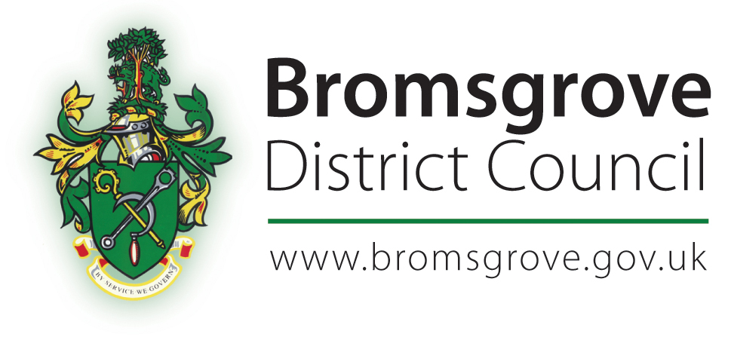

COUNCIL TAX SUPPORT SCHEME

Council Tax Hardship Fund Policy

CONTENTS

1. | Background
2. | Council Tax Hardship Fund and Equalities
3. | Purpose of this policy
4. | Statement of objectives
5. | Awarding a Hardship Fund Payment
6. | Publicity
7. | Making a claim
8. | Change in circumstances
9. | Duties of customer
10. | Amount and duration of award
11. | Payment of award
12. | Overpayments
13. | Notification of an award
14. | Reconsidering decisions
15. | Fraud
16. | Legislation

1. BACKGROUND

The Council Tax Hardship Fund has been set up by Bromsgrove District Council to cover the shortfall between Council Tax liability and payments of Council Tax Support, in cases of exceptional hardship.

Every customer who is entitled to Council Tax Support and who has a shortfall is entitled to make a claim for help from the Fund.

The main features of the Fund are that:

- Hardship Fund awards are discretionary.
- Customers do not have a statutory right to an award.
- The Hardship Fund Policy is held within the main Council Tax Support scheme.
- Hardship Fund awards are not a payment of the main Council Tax Support scheme.
- Only working age customers can make an application.
- Only those in receipt of Council Tax Support can make an application.
- Bromsgrove District Council may decide that a backdated award is appropriate; which could then settle council tax arrears. This would be the only circumstance where the Hardship Fund could be used to facilitate payment of Council Tax arrears accrued as a result of changes to Council Tax Support.

In addition to this fund there is a Discretionary Housing Payments scheme which covers the shortfall between rent and Housing Benefit, as well as other avenues of support that we would consider on a case by case basis.

2. COUNCIL TAX HARDSHIP FUND AND EQUALITIES

The creation of a Council Tax Hardship Fund facility meets Bromsgrove District Council’s obligations under the Equalities Act and ensures that appropriate transitional arrangements are in place where exceptional hardship is proven.

The Government has been clear that, in developing a local Council Tax Support scheme, vulnerable groups should be protected. Other than statutory protection for pensioners, the Government has not prescribed the other groups that local Councils should support. Bromsgrove District Council has designed their Council Tax Support scheme to take account of the various statutes that currently protect vulnerable people, and individual cases will be considered in order that the most appropriate support is provided.

We recognise the importance of protecting our most vulnerable customers and also the impact these changes have. We have created the Hardship Fund to ensure that we protect and support those most in need. The Hardship Fund is intended to help in cases of extreme financial hardship rather than support a lifestyle.

3. PURPOSE OF THIS POLICY

The purpose of this policy is to specify how Bromsgrove District Council will operate the scheme, and to indicate some of the factors which will be considered when deciding if a Hardship Fund payment can be made.

Each case will be treated on its own merits and all customers will be treated fairly and equally in the accessibility to the Fund and also the decisions made with applications.

Where a customer is not claiming a Council Tax discount to which they may be entitled or a welfare benefit or additional financial assistance, they will be advised, and assisted in making a claim to maximise their income, before their claim for Hardship Funds will be decided.

4. STATEMENT OF OBJECTIVES

Bromsgrove District Council will, through the operation of this policy, aim to:

- Allow a short period of time for someone to adjust to unforeseen short-term circumstances and to enable them to “bridge the gap” during this time.
- Support people in managing their finances.
- Help customers through personal crisis and difficult events that affect their finances.
- Aim to help prevent exceptional hardship.
- Support vulnerable young people in the transition to adult life.
- Help those who are trying to help themselves financially.
- Alleviate poverty.
- Sustain tenancies and prevention of homelessness.
- Keep families together.
- Encourage and support people to obtain and sustain employment.
- Give support to those who are financially vulnerable.

The Hardship Fund is a short-term emergency fund, awarded whilst the customer seeks alternative solutions.

5. AWARDING AN EXCEPTIONAL HARDSHIP FUND PAYMENT

The Bromsgrove District Council will decide whether or not to make a Hardship Fund award, and how much any award might be.

When making this decision the Bromsgrove District Council will consider:

- The shortfall between Council Tax Support and Council Tax Liability.
- The steps taken by the customer to reduce their Council Tax Liability.
- Changing payment methods, re-profiling Council Tax instalments or setting alternative payment arrangements in order to make them affordable.
- To ensure that all discounts are granted.
- Steps taken by the customer to establish whether they are entitled to other welfare benefits.
- If a Discretionary Housing Payment has already been awarded to meet a shortfall in rent.
- The personal circumstances, age and medical circumstances (including ill health and disabilities) of the customer, their partner and any dependants and any other occupants of the customer’s home.
- The difficulty experienced by the customer which prohibits them from being able to meet their Council Tax Liability, and the length of time this difficulty will exist.
- Shortfalls due to non-dependant deductions.
- The income and expenditure of the customer, their partner and any dependants or other occupants of the customer’s home.
- How deemed reasonable expenditure exceeds income.
- That all income may be taken into account, including those which are disregarded when awarding Council Tax Support.
- Any savings or capital that might be held by the customer or their partner.
- Other debts outstanding for the customer and their partner.
- Whether the customer has already accessed or is engaging for assistance with budgeting and financial/debt management advice. A Hardship Fund award may not be made until the customer has accepted assistance either from the Council or third party, to enable them to manage their finances more effectively, including the termination of non-essential expenditure.
- The exceptional nature of the customer and/or their family’s circumstances that impact on finances.
- The length of time they have lived in the property.
- The list is not exhaustive and other relevant factors and special circumstances will be considered.

An award from the Hardship Fund does not guarantee that a further award will be made at a later date, even if the customer’s circumstances have not changed.

A Hardship Fund award may be less than the difference between the Council Tax Liability and the amount of Council Tax Support paid.

6. PUBLICITY

Bromsgrove District Council will publicise the Fund and will work with interested parties to achieve this. A copy of this policy will be made available for inspection and will be published on the Council’s website.

7. MAKING A CLAIM

A customer must make a claim for a Hardship Fund award by submitting an application to Bromsgrove District Council. An application can be made in writing, over the phone, or in person at one of the Council offices. Customers can get assistance with the completion of an application from the Revenues and Benefits Service, Customer Services or other agencies such as bdht, or the CAB.

Applicants will be contacted and an appointment made to meet to discuss the customer’s needs. This can be in the customer’s own home or at an appropriate office. Supporting information or evidence must be provided, as reasonably requested by the Council.

In most cases the person who claims the Hardship Fund award will be the person entitled to Council Tax Support. However, a claim can be accepted from someone acting on another’s behalf, such as an appointee, if it is considered reasonable.

8. CHANGE IN CIRCUMSTANCES

Bromsgrove District Council may revise an award from the Hardship Fund where the customer’s circumstances have changed which either increases or reduces their Council Tax Support entitlement.

9. DUTIES OF CUSTOMER

A person claiming a Hardship Fund Payment is required to:

- Give the Council such information as it may require to make a decision.
- Tell the Council of any changes in circumstances that may be relevant to their on-going claim.
- Give the Council such other information as it may require in connection with their claim.

10. AMOUNT AND DURATION OF AWARD

Both the amount and the duration of the award, or any other support, are determined at the discretion of the Council and will be done on the basis of the evidence supplied and the circumstances of the claim.

- The start date will determined on individual circumstances of each case.
- The Hardship Fund will normally be awarded for a minimum of one week.
- The maximum length of the award will not exceed the end of the financial year in which the award is given.

11. PAYMENT OF AWARD

A Hardship Fund award will be made directly into the customer’s Council Tax account, thus reducing the amount of Council Tax payable.

12. OVERPAYMENTS

Overpaid Hardship Fund awards will generally be recovered directly from the customers Council Tax account, thus increasing the amount of Council Tax due and payable.

13. NOTIFICATION OF AN AWARD

When an application is approved the applicant will be issued with a revised Council Tax Bill and a covering letter to confirm the period and amount of award

14. RECONSIDERING DECISIONS

If the customer disagrees with a decision in respect of an application for a Hardship Fund they will be given one calendar month to ask us to reconsider.

When we are asked to reconsider a decision the case will be passed to a Manager, who will review the reasons for the original decision and take into account any new information supplied. The customer will informed in writing of the reviewed decision, and associated reasons for that decision.

There no further appeal rights against a decision made on a Hardship Fund application.

15. FRAUD

Bromsgrove District Council is committed to protecting public funds and ensure funds are awarded to the people who are rightfully eligible to them.

A customer who tries to fraudulently claim a Hardship Fund award by falsely declaring their circumstances, providing a false statement or evidence in support of their application, may have committed an offence under The Fraud Act 2006.

Where the Council suspects that such a fraud may have been committed, this matter will be investigated as appropriate and may lead to criminal proceedings being instigated.

16. LEGISLATION

The Local Government Finance Act 2012 amends Section 13A of the Local Government Finance 1992 and sets out the requirement for Councils to develop and adopt a localised Council Tax Support Scheme. This Hardship Fund Policy forms part of this Scheme.

