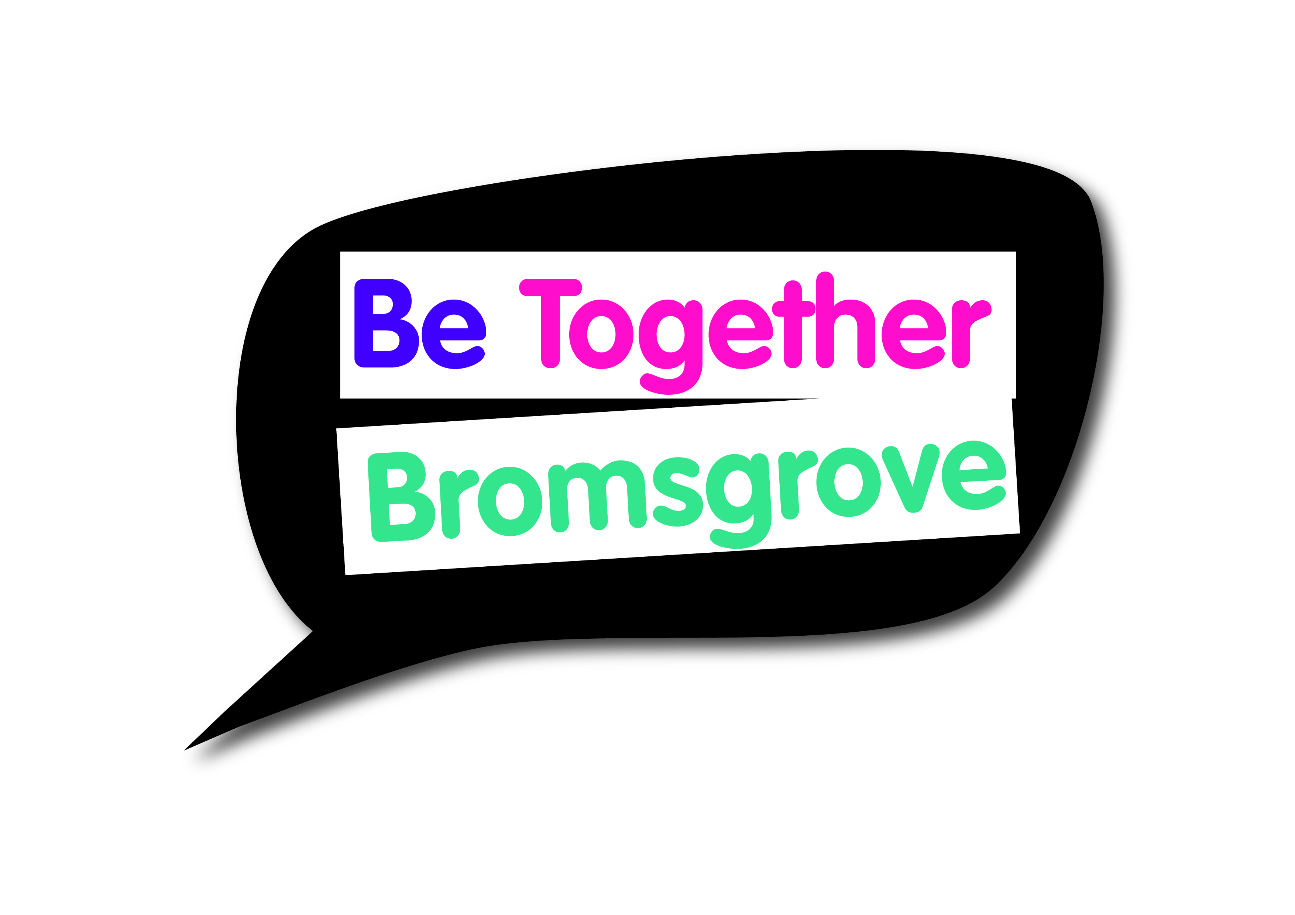
Bromsgrove Engagement & Equalities Forum
Minutes of meeting on
Thursday 8 March 2018

Attending
16 local residents/community representatives

- Introductions and apologies
Everyone was welcomed by the Chair. Introductions were made and apologies noted as above.

- Draft minutes of meeting held on 7 December 2017
The minutes were agreed

- Sgt. King – Local Policing Update
Sgt King provided an overview of changes in local policing and also in relation to the National picture. Many cuts have required changes to service delivery.
Local officer information can be found at:
https://www.westmercia.police.uk/article/5514/Bromsgrove-Police-and-Fire-Station

Hate Crime was raised as an area of interest for the forum – Sgt. King explained that Hate Crime is a force priority (including racial crime). Police aim to visit people as soon as possible following an incident.
Q. – Are you trained in supporting/working with people with severe learning difficulties and mental health issues?
A. – Yes, we are all trained to deal with people depending on their individual needs. Mental health training takes places regularly and we also have regular guest speakers.
Sgt. King is a dyslexia champion.
When someone is brought into custody, nurses are on site and will assess anyone who may have or be suspected to have a learning disability or disability. Everyone is risk assessed, and any doubt at all a referral to the Nurse is made and an appropriate adult obtained (if appropriate). There is a voluntary scheme in place for those without an adult available).

Action: Add youth engagement focus of police to June agenda.

Q. – Are there plans to merge police teams?
A. – Previously plans were considered, however these are no longer in place and Bromsgrove will remain as its own team with its own Sergeant.

Action: Police and forum to build links and look at ways they can work together to best support each other and meet overall objectives to improve the community.

Action: Rachel to locate information on Safe Place scheme and directory of places.
Please see link below for further information:
http://www.ourway.org.uk/our-way-projects/safe-place-scheme/

Q. – Parking on paths a real issue
A. – This is something for police to deal with, however all jobs have to be prioritised on levels of threat, harm and risk. Police will attend if possible.
Preventative work is already taking place with local schools, getting information to and educating parents. Further work of police discussed to tackle this problem.

Action: Forum to consider how they can work with police and the community more to support these pieces of work. Multi agency approach needed, the forum offers valuable insight from the perspective of vulnerable/disabled/wheel chair users with issues such as this.

Contact information for Police Sergeant 3472 David King
Emergency Number: Call 999
Telephone: 101 (In an emergency always call 999)
Email: bromsgrovesj.snt@westmercia.pnn.police.uk

Safer Neighbourhood teams
- Bromsgrove North and Rural
- Bromsgrove South and Rural
- Bromsgrove St Johns

- Bromsgrove Car Park Review – Update
Cheryl provided an update on the car park review in Bromsgrove.
Bromsgrove District Council commissioned 2020 Consultancy to undertake a car park, access and servicing review in Bromsgrove Town Centre. This has been an extensive and far reaching piece of work undertaken over the past 3 months.
The second draft report has been received from 2020 Consultancy which is being reviewed by the Council in terms of meeting the brief.
The review is a study which will guide Officers and partners to agree recommendations for consideration by Bromsgrove District Council which in turn will be co-ordinated to form one or more strategies.

Active discussion took place with queries around the processes taken within the review and suggestions of improvements/changes that should be considered made.

Action: Cheryl will look into who participated in the consultation that has taken place so far. The forum raised concern that they had not been involved, and specific services representing those with protected characteristics such as Guide Dogs for the Blind were raised as essential to ensuring the process is inclusive and looking at the needs of all.

- Presentations from groups who received a grant from BDC Small Grants Round 2 2017/18

Inclusive Golf
Andy delivered a presentation for the £364 received by Disability Sport Worcester to provide inclusive golf at Hagley Golf Club for young people.
Huge thank you was given to the forum and BDC for providing the money – the project has been a huge success and due to this has continued post funding. Families have greatly benefitted and a very moving video was shared of a Mother talking about the impact this opportunity has had for her and her Son.

Interesting/worrying facts shared – future thought and action by the forum to look at this?
19% of people in Worcestershire have a disability
20% of those people do 30 minutes exercise per week
Whereas;
42% of non-disabled people do 150 minutes of exercise per week

http://www.disabilitysportworcester.org.uk/

Lickey PHAB Club
Louise gave a big thank you to the forum and BDC for the £150 received for their Christmas Party. Louise delivered a presentation demonstrating the fantastic work and opportunities the club provides for its members. There was a lot of great feedback shared from those who attended the Christmas party, as well as other events the club runs.

https://www.phab.org.uk/phab-clubs-your-nearest-club

Bromsgrove Blaze Basketball Club - Wheelchair Basketball
Great thanks for the grant received, update given to the forum on the various clubs and work taking place. Forum shared advice on funding opportunities.

Age UK
Big thanks given for the money received to update wheelchairs – press release will be done soon.

- BRUG update
Bromsgrove Rail User Group were due to attend and present to the forum, however due to the change of date were unable to attend. Discussion held on the decision made to further delay installation of the lift at Barnt Green Station.

Action: BRUG to be invited to a future meeting
Action: As a forum – should a letter be put together to the Minister for Disabled?

- Pull up banner
2 designs were shared with the forum – the original had been emailed to all for comments, the second one was an updated one following the feedback that was received.
The forum preferred the updated version – change to be made to wording.

Action: Suggestions for wording on the banner to be emailed to Rachel within one week.
Final decision will then have to be made on a majority decision.
Action: Rachel to then update the banner design and agree final design with the forum.

- Update from Bromsgrove and Redditch Welcomes Refugees
Margaret read out an update from BRWR and this is attached with the minutes.
18th – 24th June is refugee week.

- Future topics for discussion/agenda item
Town centre focus – invite Cheryl Welsh to return to discuss wider topics

- Next meeting
The next meeting is Thursday 7 June, 5.30pm for refreshments with a 6pm start.

The focus will be on young people – Actions: Think about how the involvement of young people in the forum can be increased? What work do you already do to support, engage with and empower young people?

- Any Other Business including questions for the Chief Executive Officer
Bourneheath Social Club
Set up to tackle loneliness and isolation – good turnout for first meeting. Louise is seeking ideas and support – good discussions took place amongst the forum.

- Meetings for 2018

Thursday 6 September
Thursday 6 December

All meetings will be held in the Committee Room at Parkside. Refreshments from 5.30pm with the meeting starting 6pm to 8pm
Unfortunately, there is no parking, except for Blue Badge holders. Alternative parking in Bromsgrove is available at http://www.bromsgrove.gov.uk/my-place/parking/our-car-parks.aspx

