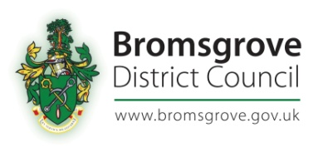

Register of Assets of Community Value
Asset Name | Asset address | Date of Receipt | Nominator | Other interested parties | End of interim moratorium | End of full moratorium | Protected period ends | Listing Ends
Hagley Library | Worcester Road  Hagley  DY9 0NW | 1st April 2015 | Hagley Parish Council |  |  |  |  | 1st April 2020
The Cross Inn | 34 Alcester Road  Finstall, Bromsgrove  B60 1EW | 6th April 2016 | Redditch & Bromsgrove CAMRA. |  |  |  |  | 6th April 2021
Catshill & District Working Men’s Club Limited | 13a Meadow Road  Catshill  Bromsgrove  B61 0JJ | 23rd March 2017 | Redditch & Bromsgrove CAMRA. |  |  |  |  | 23rd March 2022
Methodist Church Hall | Greenhill, Blackwell,  B60 1BL | 1st November 2017 | Lickey and Blackwell Parish Council |  | 11Th December 2017 | 30th April 2017 |  | 1st November 2022
Wythall Community Centre/Park | 52 Silver Street, Wythall, B47 6LZ | 26th February 2019 | Wythall Parish Council |  |  |  |  | 26th February 2024
High House Wood | High House Lane,  Lickey, B45 | 18th September  2019 | Lickey and Blackwell Parish Council |  |  |  |  | 18th September 2024

