Notice of Review of

Bromsgrove District Council
Polling Districts and Polling Places
Over the next few months Bromsgrove District Council will be undertaking a full formal review of all polling districts & polling places within its area.
The review begins with immediate effect; Officers will then draw up proposals in a draft report, which will contain details of representations received, including any of the Interim (Acting) Returning Officer.
As part of this process:
- Any elector from within the District Council area may make representations, during the consultation stage (2 October to 13 November);
- the Interim (Acting) Returning Officer will also be commenting on proposed polling stations, and any such representations will be placed on deposit for inspection, as soon as available;
- the Council welcomes the views of all residents, particularly residents with disabilities, on the Council’s proposals, on the Interim (Acting) Returning Officer’s representations or on any other relevant matters;
- the Council welcomes any person or body with expertise in access for persons with any type of disability to comment on its proposals, on the Interim (Acting) Returning Officer’s representations or on any other matters;
- persons or bodies making representations on particular Polling Stations are asked, if possible, to suggest appropriate alternative places which might be used as polling places.
More information and a form for those wishing to make representations is available on the website.

The details of the existing electoral arrangements, and of the Review as it develops, will be available for inspection between the hours of 10.00am and 4.00pm on any normal working day at the Council Offices, Parkside, Market Street, Bromsgrove B61 8DA.
Details of all representations will also be made available for inspection.

Comments must be made in writing by 13 November and representations should be submitted either by letter or by email to:

Polling District and Polling Places Review
Electoral Services Manager
Town Hall,
Walter Stranz Square
REDDITCH
Worcestershire B98 8AH.

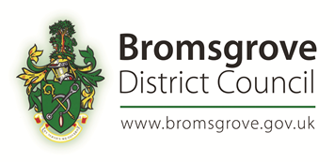
Email: elections@bromsgroveandredditch.gov.uk
Telephone Helpline: 01527 881421

Website: http://www.bromsgrove.gov.uk/pollingreview2023

Dated: 2 October 2023

