Submissions Received 2023 Review (redacted)

BR1 4/10/23 – Alvechurch Baptist Church – polling place for ALV, ALC
“I have nothing to add about the polling stations, but thank you for asking. The one in my Ward are accessible by all and there is also a free car park right next to it so I am happy.” District Councillor
BR2 5/10/23 – Hagley Community Centre – polling place for HAA, HGB, HGC
“To close the loop on the statutory review of polling stations I can say that the community centre is ideal for elections as it is central to Hagley and within safe walking distance, easy access to drive to and plenty of free parking. It is well known and has hosted elections for many years now.
This applies to all elections as Hagley is stand alone and clearly defined by greenbelt boundaries and ward boundaries.” District Councillor
BR3 5/10/23 - Friends Meeting House – polling place for BHB
“I am happy to support the continued use of this site as a polling station.” District Councillor
BR4 5/10/23 - Hopwood Village Hall – polling place for BHA
“I am happy to support the continued use of this site as a polling station.” District Councillor
BR5 14/10/23 – St Godwolds Church Hall – polling place for ASA, ASB, SSA, SSB
“This venue is too small for two wards to vote at. The parking is really poor and on a couple of occasions I noticed the car park was full.”
BR6 – 12/10/23 - Fairfield Village Hall – polling place for BRB
“Fairfield Village Hall may be out of the way for those residents living in Wildmoor that do not have transport (majority do have transport). There is, at present, no available venue that can serve as a Polling Station in the Wildmoor area. This could change if the Wildmoor Oak public house reopens.
The furthest direct line distance between dwellings and Fairfield Village Hall, i.e. Barnes Close/Chadwich Grange, is approximately 2 miles.
Fairfield Village Hall is suitable as a Polling Station and is conveniently located for most residents. The Hall is fully accessible, with ample parking, to meet the needs for a polling station, comfortable chairs, suitable tables, has natural and artificial light and is warm.
We do not see any reason why Fairfield Village Hall should not continue as a Polling Station.
Fairfield Village Community Association would prefer no changes to be made to existing arrangements for using Fairfield Village Hall. Many older residents would struggle to get to a polling station that is located elsewhere, e.g. Bournheath Village Community Centre or in Belbroughton.” Fairfield Community Association
BR7 – 10/11/23 - Tardebigge church hall– polling place for TAC
“This facility is fit for purpose for the task as polling station.”
BR8 – 17/10/23 - Beoley Village Hall – polling place for ALB
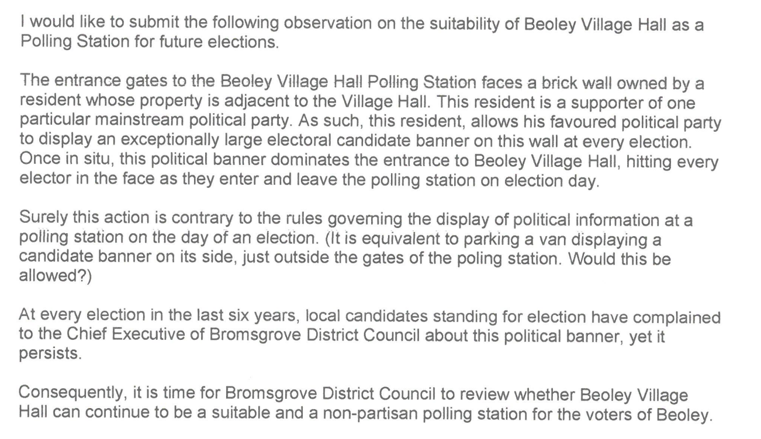
BR9 15/10/23 – St Godwolds Church Hall – polling place for ASA, ASB, SSA, SSB
“Slideslow has historically used Finstall First School as a polling place, however, for May’s local elections, St Godwalds Church was used instead. I would be strongly against using St Godwalds Church again for Slideslow as parking arrangements are not sufficient at the Church, particularly when it is already being used as a polling place for Aston Fields.
Furthermore, the polling place itself is not in the ward, meaning residents had to travel a fair distance to get there to vote which may sadly deter some from voting. Although I recognise that there is a boundary review underway which may change the boundaries, sizes, names and number of councillors per ward, at present I strongly believe that a location within the Slideslow ward should be used for Slideslow voters, particularly when Finstall First School has been used historically which is within the ward.
Moreover, there was some confusion among voters about St Godwalds Church being the polling place in May. One resident in particular showed up at Finstall First School to vote and had to rush over to St Godwalds Church just before 10PM to cast his vote in time. He raised this with me as I was telling on the polling place at the time. Although, the polling place is displayed on the polling card, it appears there was miscommunication about the change to St Godwalds.
I recognise that the initial officer review comments state: “The polling place has recently been moved to St Godwald's in order to move away from Finstall First School for local elections. However, this puts additional pressure on facilities and parking at St Godwald's and therefore it is not recommended St Godwalds be used at a general election for either SSA or SSB”.
I agree that St Godwalds should not be used at a general election for Slideslow, however, I would go further and suggest that it is not used at local elections or PCC elections either. If Slideslow residents are to vote at Finstall First School in general elections and St Godwalds during other elections, this will create a lot of confusion among residents. I believe we should be consistent in our approach and not use St Godwalds Church for Slideslow at all.” District Councillor
BR10 10/11/23 – Catshill Social Club – polling place for CAS
“The polling station at Catshill Social club works well, lots of parking and space inside from recent district elections but complaints I received is that residents have to walk past the methodist church hall (CAN) to get to CAS and vis versa for CAS.” District Councillor
BR11 10/11/23 – Catshill Social Club – polling place for HWA
“I looked at this some months ago and I was happy with the current polling stations' location in Wythall & Hollywood. It could be that the boundary changes, if any, could have an impact but my gut feeling is that they won't.” District Councillor.

