

Street Trading Policy


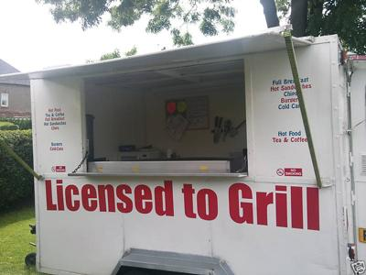


Approved to take effect on 1st December 2017
CONTENTS

SECTION | Page Number
1 Introduction  2 Designation of Streets  3 Applications  4 Duration of Consent  5 Conditions of Consent  6 Appeals  7 Complaints and Enforcement  8 Amendments to Policy  9 Fees and Charges  10 Definitions | 3  6  7  12  13  14  15  16  17  18
ANNEXES

A Form of Public Notice  B Standard Conditions | 20  21

1.0 INTRODUCTION

1.1 Bromsgrove District

1.1.1 Bromsgrove District Council is situated in the County of Worcestershire, which contains six District Councils in total. The Council area has a population of approximately 93,600 and in terms of area it covers approximately 84 square miles.

1.1.2 The Council area is mainly rural in character (90% of the area is classed as Green Belt) with two central urban areas of Bromsgrove Town and Rubery.

1.1.3 Whilst it is only 14 miles from central Birmingham, the Clent and Lickey Hills provide an important dividing line between the industrial Midlands and the rural landscape of North Worcestershire.

1.1.4 Bromsgrove District Council’s overall vision is “working together to build a district where people are proud to live and work, through community leadership and excellent services.” This policy statement accords with this overall vision and attempts to help further the Councils strategic purposes, which are:

- Keep my place safe & looking good.
- Help me run a successful business
- Help me to be financially independent
- Help me to live my life independently
- Help me find somewhere to live in my locality
- Provide good things for me to see, do & visit

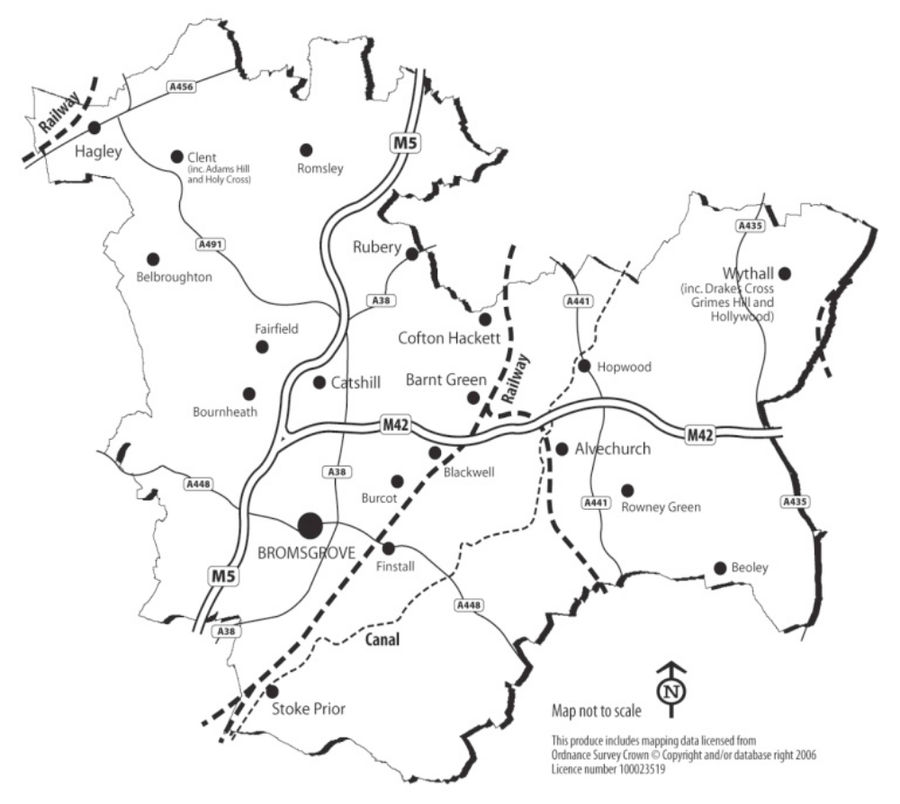

1.2 The Policy

1.2.1 This document states Bromsgrove District Council’s Policy on Street Trading, as defined by the Local Government (Miscellaneous Provisions) Act 1982 (Section 3 and Schedule 4).

    - In exercising its discretion in carrying out its regulatory functions, Bromsgrove District Council will have regard to this Policy document and the principles set out therein.

    - Notwithstanding the existence of this Policy, each application will be considered on its own merits, with reference to the principles and procedures that are detailed in this Policy.

  - The Objectives of this Policy

    - This Policy recognises the important service that is provided by street traders and the contribution they make to the local economy.

    - The objective of this Policy is to create a trading environment in which street trading complements existing premises-based retailing activities, is sensitive to the needs and concerns of residents and provides diversity in terms of consumer choice.

    - The Policy aims to ensure that street trading does not undermine safe and efficient passage along public highways.

    - This Policy aims to balance the needs of the wider community, local community and street traders, against the needs of those who may be adversely affected by the street trading activities.

    - The Policy aims to provide consistency and transparency in the way in which the Council deals with street trading and to ensure that street trading is fairly, appropriately and proportionately controlled, in line with the Regulator’s Code.

  - The Law

1.4.1 The Local Government (Miscellaneous Provisions) Act 1982 (Section 3 and Schedule 4) provides the legal framework for the control of street trading in England and Wales. This activity is defined as “the sale and exposing or offering for sale any article, including a living thing, in a street.” Streets are further defined as to include any road, footway, beach, or other area to which the public have access without payment.

    - The main purpose of this legislation is to establish an appropriate regulatory regime which prevents undue nuisance, interference or inconvenience to the public brought about by street trading. This legislation provides local authorities with the power to designate specific areas within their administrative boundaries as either:

- Prohibited Streets: those which are not open to street traders
- Consent Streets: where street trading is prohibited without Local Authority consent
- Licence Streets: where trading is prohibited without a Local Authority licence

    - Local authorities can place conditions on any Consent or Licence granted. The Act also creates offences associated with trading in Consent or Licence streets without the necessary authority: the person guilty of such an offence may be liable, on conviction, to a fine of up to £1000.

    - There are, however a number of exemptions provided in the Act, which are not considered to be street trading. These are detailed in Section 10 below (definition of ‘Street Trading’). However it is important to note that exempted traders are still controlled by other regulatory legislation.

1.5 Licensing Act 2003

1.5.1 It should be noted that should a street trader wish to sell alcohol or provide late night refreshment, additional authorisation will be needed under the terms of the Licensing Act 2003.

    - Late night refreshment is the supply of hot food or drink between the hours of 11pm and 5am on any day of the week.

    - Licensing Officers will be able to provide further information on the requirements of the Licensing Act 2003.

- DESIGNATION OF STREETS FOR THE PURPOSES OF STREET TRADING

2.1 Consent Streets

2.1.1 Bromsgrove District Council has resolved to designate all streets in the District (as existing at the time of the making of the resolution and in the future) as consent streets with effect from 1st December 2017.

- APPLICATIONS FOR A STREET TRADING CONSENT

3.1 Advice for New Applicants

3.1.1 New applicants are advised to contact the Council at their earliest opportunity, preferably before an application is made. This allows Officers to provide advice, as well as clarifying any areas of uncertainty.

    - It is the responsibility of the applicant, in the first instance, to identify the location(s) in which they wish to trade as there is no designated list of street trading “pitches” that can be traded from.

    - The Council can also provide advice in relation to other legal requirements of a new Consent Holder, for example, planning permission or food safety requirements.

3.2 Applications

3.2.1 All applications for grant or renewal of a Street Trading Consent must be made on the Council’s prescribed application form.

    - Each application must be accompanied by the prescribed application fee. An application will not be considered as duly made until the prescribed application fee has been received.

3.2.3 The following will also be required to be submitted with the application form:-

- Where the proposed trading is from a fixed location, a copy of a plan at a minimum scale of 1:2000, unless an alternative scale has been specified by a Licensing Officer. This plan should clearly identify the proposed site location by marking the site boundary with a red line.

- Where the trading is proposed to take place on a mobile basis, a list of the relevant Towns/Parishes in which trading is proposed to take place providing details where possible about specific areas.

- Confirmation that an adequate level of third party public liability insurance is, or will be, in place during street trading activity.

- Where the trading is to take place from private land, documentary evidence that the landowner has given their consent to the applicant to trade from their land.

- Two passport sized photographs of the applicant and any person who will be assisting with the trading on a regular basis. One of the photographs of each person must be endorsed with a statement verifying the likeness of the photograph to the applicant by a solicitor, notary, a person of standing in the community or any individual with a professional qualification.

- A colour photograph of any trailer, stall or other vehicle from which the street trading activities are proposed to take place.

- Food hygiene certificates (where relevant)

- Proof of registration as a food business (where applicable)

- Satisfactory certificates confirming the safety of any gas or electrical installations within the trailer, stall or vehicle from which the street trading activities are proposed to take place.

- Certificates to confirm that any fire fighting equipment within the trailer, stall or vehicle from which the street trading activities are proposed to take place have been appropriately serviced and maintained.

- If a vehicle is to be used as part of the street trading activities, registration details of the vehicle including confirmation of the registered keeper of the vehicle and their address.

- Proof of the applicant’s address and of their right to live and work in the United Kingdom.

3.2.4 Applications cannot be considered from anyone under the age of 17.

3.3 Processing an Application

3.3.1 Applications for grant or renewal of a Street Trading Consent will be notified by the Council to the following:-

- West Mercia Police
- Worcestershire County Council (Highways)
- Highways England
- The relevant Parish Council(s)
- The District Councillor(s) for the Ward(s) concerned
- Environmental Health Officers at Worcestershire Regulatory Services
- The Planning Authority
- Safer Bromsgrove
- Bromsgrove District Council Environmental Services
- North Worcestershire Economic Development and Regeneration (NWEDR) team
- Trading Standards
- The owners / occupiers of any residential and/or business properties in the vicinity of the proposed location of any static trading site.
- Any other relevant organisation

    - Additionally, where the application is for grant of a new Consent in respect of a fixed location, the applicant must also advertise their application by displaying the prescribed Public Notice at the relevant location for not less than 21 days beginning with the day after the application for Consent is made to the Council. The form of the Public Notice required is shown at Annex A to this Policy.

3.3.3 The Council will allow 28 days from the date that the application is received and confirmed as valid, for people to make representations or objections in relation to the application.

3.3.4 Representations or objections will be accepted from any of the bodies listed at 3.3.1 and any other individual or business that can demonstrate that they would be materially affected by the proposed street trading activities.

3.4 Determining Applications with no Representations or Objections

3.4.1 Where no representations or objections are received within 28 days of the application being received, Officers will grant Consent to the applicant in the terms that it was applied for.

3.5 Determining Applications through Mediation

    - Where a representation or objection is received in respect of an application, a Licensing Officer will, in the first instance, attempt to mediate between the relevant parties.

3.5.2 For example, it may be possible to find a compromise position in one of the following ways:-

- amending the times during which trading will take place;
- amending the days on which trading will take place;
- adding conditions to the Consent to address specific concerns;
- granting Consent for a trial period to assess the impact; or
- amending the list of articles to be sold.

3.5.3 Where all relevant parties agree to a compromise position, the Consent will be granted by Officers, subject to the agreed amendments.

3.6 Determining Applications Where Mediation Is Not Possible

    - Where representations or objections are received and it is not possible to reach an agreed compromise, the application can be referred, at the applicant’s request, to the next available Licensing Sub-Committee for determination.

3.6.2 The Licensing Sub-Committee will be conducted in accordance with the Council’s standard procedure.

3.7 Key Considerations

    - Each application will be considered on its own merits.

    - The Council will have regard to all of the circumstances and all of the representations and objections that it receives. The Council will normally grant or renew a Street Trading Consent unless, in its opinion,:-

- a significant effect on road safety would arise either from the siting of the trading activity itself, or from customers visiting or leaving the site; or
- there are concerns over the recorded level of personal injury accidents in the locality where the street trading activity will be sited; or
- there would be a significant loss of amenity caused by traffic, noise (whether from trading unit or its customers), light pollution, rubbish, air quality, potential for the harbourage of vermin; or
- there is already adequate like provision in the vicinity of the site to be used for street trading purposes; or
- there is a conflict with Traffic Orders such as waiting restrictions; or
- the site or pitch obstructs either pedestrian or vehicular access, or traffic flows, or places pedestrians in danger when in use for street trading purposes; or
- street trading activities would undermine the safe and efficient passage along public highways and cause congestion; or
- the pitch interferes with sight lines for any road users such as at road junctions, or pedestrian crossing facilities; or
- the site does not allow the Consent Holder, staff and customers to park in a safe manner; or
- the trading activity would detract from the visual or other attractions of the area in which it takes place, particularly designated Conservation Areas, Areas of Outstanding Natural Beauty and Sites of Special or Scientific Interest; or
- street trading activities would conflict with the solemnity and tranquillity that can reasonably be expected at sensitive locations, such as close to a place of worship, cemetery, crematorium etc; or
- the street trading activity is carried out after dusk and the site is not adequately lit to allow safe access and egress from the site for both customers and staff; or
- a Consent has already been granted to another person to trade similar articles in the immediate vicinity.
- the proposed consent holder is not considered to be a suitable person to be granted a street trading consent for any reason.

3.8 Options Available to Licensing Sub-Committee

    - When determining an application for grant or renewal of a Street Trading Consent, a Licensing Sub-Committee can take any of the following steps as is considered desirable with a view to meeting the objectives of this Policy:-

(a) grant consent to the applicant as applied for;

(b) grant consent to the applicant subject to modifications to any of the following matters:

- the days on which trading can take place;
- the times during which trading can take place;
- the location(s) where trading can take place;
- the articles that can be traded;
- the conditions attached to the Consent;
- the duration of the Consent.

- refuse to grant Consent.

3.8.2 In the interests of transparency, reasons will be given for any decision taken by a Licensing Sub-Committee.

3.9 Grant of Consent

3.9.1 The grant of a street trading consent does not guarantee the holder of the Street Trading Consent unimpeded access to the location(s) where they are permitted to trade.

3.9.2 There may be occasions where the trading location(s) specified on the Street Trading Consent may be unavailable to the holder of the Street Trading Consent for reasons beyond the control of the Council.

4.0 DURATION OF STREET TRADING CONSENTS

4.1 Duration

4.1.1 A Street Trading Consent may be granted for any period not exceeding 12 months, but may be revoked at any time.

4.1.2 The holder of a Street Trading Consent may at any time surrender their Consent to the Council, and it shall then cease to be valid

    - A Street Trading Consent will normally be granted for 12 months and will then expire.

    - The Council will consider granting a Street Trading Consent for a shorter duration than 12 months on application.

    - A Street Trading Consent may be granted for a shorter period as determined either through the mediation process described at Paragraph 3.5 or by a Licensing Sub-Committee. Consents lasting less than 12 months may be granted to provide a “trial period” during which any adverse impact of the trading can be assessed.

4.2 Renewal

4.2.1 Applications to renew an existing Street Trading Consent must be made at least 28 days prior to the expiry of the existing Consent.

4.2.2 If applications for renewal are not received at least 28 days prior to the expiry of the existing Consent, applications from other prospective traders wishing to trade at the relevant location will be considered.

5.0 CONDITIONS ATTACHED TO CONSENTS

5.1 Standard Conditions

    - When granting or renewing a Street Trading Consent, the Council may attach such conditions to it as they consider reasonably necessary.

    - Street Trading Consents will usually be granted subject to the standard conditions detailed in Annex B to this Policy.

5.2 Additional Conditions

    - Additional conditions, over and above the standard conditions, may be imposed on a Street Trading Consent on a case by case basis. Additional conditions may be attached either as a result of the mediation process described at Paragraph 3.5 or by a Licensing Sub-Committee when granting Consent.

6.0 APPEALS

6.1 Refusals / Attached Conditions

    - The Act does not provide an applicant with any direct right of appeal against a decision to refuse the grant or renewal of a Street Trading Consent, the revocation of a Street Trading Consent, or against any restrictions or conditions imposed on a Street Trading Consent.

7.0 COMPLAINTS AND ENFORCEMENT

7.1 General Principles

7.1.1 It is recognised that well-directed enforcement activity by the Council benefits not only the public but also responsible members of the trade.

7.1.2 All decisions and enforcement actions taken by the Licensing Authority will be taken in accordance with the Regulator’s Code.

7.2 Offences

7.2.1 The following are offences under Schedule 4 of the Local Government (Miscellaneous Provisions) Act 1982:-

- engaging in street trading in a prohibited street;
- engaging in street trading in a consent street without Consent;
- contravention of a condition in relation to trading location; and
- contravention of a condition in relation as to the times between which or periods for which a Consent Holder can trade.

7.3 Complaints

7.3.1 Where complaints are received regarding the carrying on of street trading activities, these will be investigated in a prompt and professional manner.

    - If a complaint is found to be justified then the following actions may be taken by Officers:-

- verbal warning;
- written warning;
- simple caution;
- prosecution; or
- referral of the Consent Holder to a Licensing Sub-Committee.

    - If an existing Consent Holder is referred to a Licensing Sub-Committee, the Licensing Sub-Committee may take any of the following steps as are deemed desirable to meet the objectives of this Policy:-

- take no further action;
- give a warning to the Consent Holder;
- amend the days on which trading can take place;
- amend the times during which trading can take place;
- amend the location(s) where trading can take place;
- amend the articles that can be traded;
- amend the conditions attached to the Consent;
- amend the duration of the Consent; or
- revoke the Consent.

8.0 AMENDMENTS TO THIS POLICY

8.1 Any significant amendment to this Policy will only be implemented after further consultation with the trade and the public.

For the purpose of this section, any significant amendment is defined as one that:-

a) is likely to have a significant financial effect on licence holders;
b) is likely to have a significant procedural effect on licence holders; or
c) is likely to have a significant effect on the community.

9.0 FEES AND CHARGES

9.1 The fees charged by the Authority for Consents to trade should at least cover the cost of administering and enforcing the service.

9.2 The fees will be reviewed at least on an annual basis and published on the Council’s website.

9.3 It is possible for the Authority to charge different fees for Consents that are for different durations or locations. Different fees can also be charged depending on the nature of the articles being sold and depending on whether the trading takes place at a single location or on a mobile basis.

9.4 Street trading fees may be waived at the discretion of the relevant Corporate Head of Service, acting in consultation with the Chairman and Vice-Chairman of the Licensing Committee. Fees may only be waived in relation to charitable or community events, or events of a similar nature. Each event will be judged on its own merits.

- DEFINITIONS

TERM | DEFINITION
Authorised Officer | An Officer of the Council authorised by it to act in accordance with the provisions of the Local Government (Miscellaneous Provisions) Act 1982.
Consent | A Consent to trade on a street granted by the Council, pursuant to Schedule 4 of the Local Government (Miscellaneous Provisions) Act 1982.
Consent Holder | The person or company to whom the consent to  trade has been granted by the Council.
Consent Street | A street in which street trading is prohibited without the consent of the Council.
Council | Bromsgrove District Council
Days | Refers to consecutive or calendar days unless specified otherwise.
Prohibited Street | A street in which street trading is prohibited
Street | Any road, footway or other area to which the public have access without payment, or any part of a street, including all roads, footways and areas open as a matter of fact to the public without payment, within the distance of 30 metres from the centre of those streets which are part of the public highway.
Street Trading | The selling or exposing, or offering for sale of any article (including a living thing) in any street. The following are not street trading for the purposes of this Policy:-  - a pedlar with a Pedlar’s Certificate;  - anything done in a Market or Fair the right to hold which was acquired by virtue of a grant (including a presumed grant) or acquired or established by virtue of an Enactment or Order;  - trading in a trunk road picnic area provided by the Secretary of State under Section 112 of the Highways Act 1980;  - trading as a newsvendor selling only newspapers/magazines;  - trading which is carried out at premises used as a petrol filling station, or at premises used as a shop, or in a street adjoining premises so used, and as part of the business of the shop;  - selling things, or offering or exposing them for sale, as a roundsman;  - the use for trading, under Part VIIA of the Highways Act 1980, of an object or structure placed on, in or over a highway;  - the operation of facilities for recreation or refreshment under Part VIIA of the Highways Act 1980;  - the doing of anything authorised by regulations made under Section 5 of the Police, Factories etc (Miscellaneous Provisions) Act 1916.
Street Trading Assistant | A person engaged by the Consent Holder to assist them with their trading.  A street trading assistant will be deemed to be assisting a Consent Holder on a regular basis if they will be engaged to assist them on more than 14 days per calendar year.

ANNEX A

NOTICE OF APPLICATION FOR GRANT
OF A STREET TRADING CONSENT

Name of Applicant
Location
Summary of application (hours of trading, articles to be sold, etc):

NOTICE IS HEREBY GIVEN that an application has been made to Bromsgrove District Council for a Consent to carry out street trading at the above location

Copies of Schedule 4 of the Local Government (Miscellaneous Provisions) Act 1982 (which defines the type of activity that may be carried on under a Consent) and of the application may be inspected at the Customer Contact Centre, Parkside, Market Street, Bromsgrove, Worcestershire, B61 8DA between 9.00 am and 4.00 pm (Monday to Friday except public holidays).

Any representations or objections in respect of the above application must be made in writing to the council at the above address by

_____________________________________________
(28 days after the date of the application)

ANNEX B
STREET TRADING CONSENT
STANDARD CONDITIONS

LOCAL GOVERNMENT (MISCELLANEOUS PROVISIONS) ACT 1982

Street Trading Consents are issued by this Council subject to the following Standard Conditions, in so far as they do not conflict with, or are amended by, any special conditions imposed on the grant of a Consent:-

Nothing herein contained shall prejudice the rights, powers, duties and obligations of the Council or any other enforcing authority under any public or private statutes, orders, regulations or byelaws.

- The Consent shall be valid for the period specified in the Consent, but this period shall not exceed 12 months.

- The Consent may be revoked by the Council at any time, including as a result of a breach of these conditions.

- A Consent shall be required for each trading unit (e.g. each vehicle or stall).

- A Consent shall not be assigned or transferred.

- Street trading must only be carried on by the Consent Holder or by a person engaged by the Consent Holder to assist in their trading.

- The Consent Holder must provide details and proof of the name, address, date of birth and a photograph of any person assisting them with their trading on a regular basis.

- The Consent Holder must notify the Council of any change to their address or the address of any person assisting them with their trading on a regular basis.

- Any person assisting a Consent Holder on a regular basis must be at least 17 years of age.

- Consent Holders, and any person assisting them on a regular basis, shall at all times, clearly and visibly display a valid identification badge. The badge is to be issued by the Council.

- The Council may vary or make additions to the Conditions or a Consent at any time.

- The Consent shall be limited to the days of the week, and between the hours each day, as stated on the Consent.

- The Consent Holder and/or his assistants shall only sell, or offer for sale, those goods specified in the Consent granted to the Consent Holder.

- The Consent Holder, and/or his assistants, shall only trade at the location(s) specified in the Consent.

- The Consent Holder or their assistants must allow Council officers to inspect their trading facilities and should offer all reasonable assistance to them.

- The Consent Holder, and/or his assistants, must not cause an obstruction of any street or endanger any person using it.

- The Consent Holder, and/or his assistants, must not cause nuisance (whether from noise, smell, litter or light) or annoyance by reason of the street trading activity, whether to persons using or living in the street or otherwise. In particular, but without prejudice to the generality of the foregoing, the Consent Holder shall ensure that his customers or patrons conduct themselves in an orderly manner.

- Where a trader trades from a fixed location, at least one refuse container must be provided for use by customers.

- When leaving a site the trader shall ensure that the locations in the immediate vicinity of where he has been trading are clear of refuse and waste arising from the trading.

- Traders must arrange the removal and disposal of waste arising from their trading in a lawful manner and produce evidence of any relevant trade waste agreement when required by an Authorised Officer or the Council.

- No waste matter shall be discharged onto a street or be allowed to enter a highway drain.

- The use and storage of liquefied petroleum gas shall comply with all current, relevant legislation and Codes of Practice.

- No television, radio, tape player or other device used for the entertainment of the Operator, shall be audible outside, or beyond, the trading unit.

- All signs advertising the business must be no more than 75 metres from the trading unit.

NOTE: The requirements as to signs advertising the business do not imply the right to display such signs which may require a necessary planning permission.

- At the end of each trading period the trader shall remove any signs advertising the business, with the exception of those attached to the vehicle or stall used for the purposes of the Street Trading Consent.

- No television, radio, tape player or other device used for the reproduction or amplification of sound during trading shall be at a level which causes nuisance or annoyance to persons using or living in the street.

- Any vehicle, stall or container used by the Consent Holder in the course of street trading shall be constructed and maintained to the satisfaction of all reasonable requirements of the Council, the Police, Fire Officer and Highway Authorities as to its construction, safety and appearance and any changes to vehicles used in the course of trading must be notified to the Council.

- The Consent holder or his employee must move his trailer, vehicle, stall or any signage associate with their trading or vacate the site immediately upon the instruction of a Police Officer or Authorised Officer of the Council.

- The Consent Holder shall at all times maintain a valid Third Party Public Liability Insurance Policy to the satisfaction of the Council and shall produce a valid certificate of such insurance at any time upon request by an authorised Officer of the Council.

- The Consent Holder must ensure any gas and electrical installations are properly maintained and the relevant safety certificates must be produced on request from an Authorised Officer of the Council.

- The Consent Holder, and/or assistants, shall not trade whilst intoxicated and should behave in a civil and orderly manner at all times when trading.

- Consent holders, and any/or assistants, should wear clean and appropriate clothing.

- The Consent Holder must notify the Council within 7 days if any of the information provided when applying for the consent changes.

A Street Trading Consent does not operate as a consent for any purpose other than to permit the holder to trade on a Consent Street in accordance with any conditions imposed. The Consent Holder must ensure that he has obtained any other consent, approval or registration required under any other statutory provision relevant to his trade.

In these conditions ”Consent” means a consent issued under Paragraph 7 of Schedule 4 of the Local Government (Miscellaneous Provisions) Act 1982; “Consent Holder” means the person named on the Street Trading Consent issued by the Council and any person employed by him to assist in his trading; “Council” means the Bromsgrove District Council.

